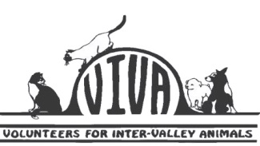

**VOLUNTEERS FOR INTER-VALLEY ANIMALS**

**APPLICATION TO VOLUNTEER AT THE CATTERY**

**Volunteers are needed every morning and every evening at our shelter to do the work of caring for our rescued animals.**

**The morning tasks include:**

* Changing every water dish/filling the dry food bowls
* Shaking each piece of bedding; washing and drying all the shelves/cubbies
* Washing/drying/folding/shelving many loads of laundry
* Cleaning out all the litter boxes; washing & drying all the litter boxes
* Washing and drying all the dishes
* Washing windows
* Sweeping and mopping all the floors
* Cleaning cages and condos
* Taking out all the garbage
* Petting/grooming the cats after work is finished

**The night tasks include:**

* Feeding the general rooms and cages
* Refilling the water dishes & dry food bowls
* Medicating cats that need it
* Cleaning out the litter boxes & sweeping up loose litter in rooms
* Taking out the garbage
* Securing the shelter for the night

**This is a real commitment. The animals depend on us, and your fellow volunteers depend on you to do your share of the work on the day/night of the week you have chosen to be here. If this is something you feel you would like to do, please fill out the following information:**

**Name:** Click here to enter text. **Address:** Click here to enter text.

**Phones: Home** Click here to enter text. **Work** Click here to enter text. **Cell** Click here to enter text.

**Which Shift is best for you? Day or Night** Choose an item.

**Have you had a tetanus shot within the last five years:** Yes/No

**If a minor, what is your transportation:** Click here to enter text.

**Signature_________________________ Date_______________________________**

**If a minor, Parent Signature :________________________ Phone :** Click here to enter text.

**Please bring your completed application to our shelter at 133 North D street in Lompoc, any morning between 9 and 11.**